CHERYL SIM

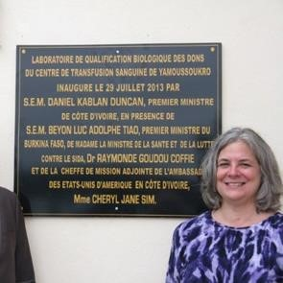
International Relations and Diplomacy Strategist
Principal
Retired U.S. Department of State Foreign Service Officer

Over the course of a 32-year career with the United States Department of State, Cheryl Sim specialized in countries emerging from conflict and their respective quests for security and stability. Ms. Sim served as the Foreign Policy Advisor to the Commanding General of the Combined Joint Task Force – Horn of Africa at Camp Lemonnier, Djibouti; the only enduring U.S. military presence in Africa. She advised the Command on bilateral, regional and multilateral issues related to East and Central Africa. Elsewhere in Africa, Ms. Sim led and managed the daily operations of the U.S. embassies in Cote d’Ivoire (2012-2014) and Rwanda (2007-2009). Ms. Sim is an acknowledged authority on Somalia and was assigned as the Counselor for Somalia Affairs and the Deputy Special Representative for Somalia at the U.S. Mission in Nairobi (2010-2012). Her other assignments in Africa were at the U.S. embassies in Antananarivo, Madagascar and Mogadishu, Somalia. She directed the Bureau of Intelligence and Research’s Office of War Crimes, Atrocities, Human Rights and Democracy (2009-10). She served as the Counselor for Political and Specialized Agencies Affairs (1999-2002) at the U.S. Mission to the United Nations in Geneva, and in the Bureau of Democracy, Human Rights, and Labor (1994-96). She holds six Department of State Superior Honor Awards and six Meritorious Honor awards.

